ITS Mobile Changes:
- Add Logoff to left drawer. 1 hr. This is implemented already. Needs to be verified.
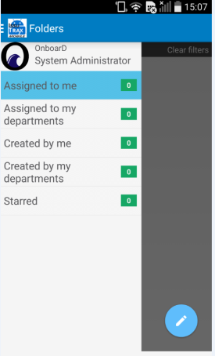

- Cache login details as you have on the other devices. 1 hr. Implemented already. Needs to be verified
- Department filter. 4 Hrs
  - We need the ability to filter by creation department and current department. Please add a radio button (Created By/Current) to the dialog that selects the department and adjust the where clause accordingly.
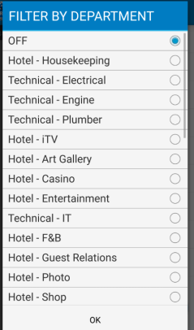
- When a user has a location group set it should filter by that location group on login. What is happening if the location group is being updated in the header (see first image) but not actually filtering. When you clear filters and reapply it works (second image). (AIDA 7) 8 hrs
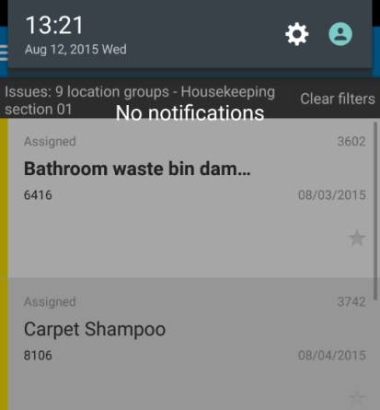
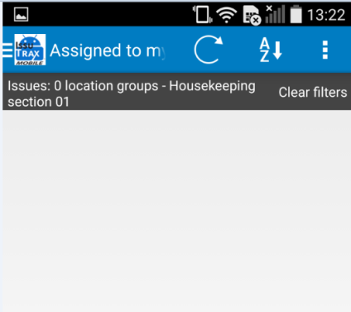
- Work flow not being respected. Example if you close an issue where guest service = yes and callback = yes the issue should go to pending guest contact. (AIDA 28) Not clear
- Users can action issues assigned to others in department (AIDA 5,15) 4 hrs
  - Issues“Assigned to my departments”, should show only issues where IssueTracks.AssigneeAnyuser = 1 (unassigned) if you are not a department manager (users.deptmgr = 0). If you are a department Manager (users.deptmgr=1) you can see all issues for departments where Permissions_Departments.CanManage=1
- Guest Details Missing: First / Last Name, fix emb and deb date as they are epoch based 4hrs
- Change default sort order to be Priority Descending. It is currently based on Issue ID. 1hr
- Change the filter labels so they are consistent and organized.(AIDA 8) 2hrs
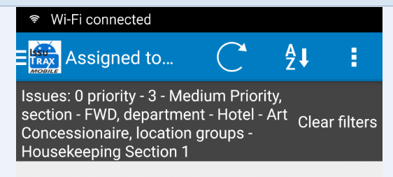
  - Please change so each that it display as “Label: value” with the label in upper case. The above image shows how it is now and this is how it should be “Issues: 0, Priority:3, Section: FWD, Department: Hotel – Art Concessionaire,Location Group: Housekeeping Section 1”
- The “Automatic Synchronize” setting in “Update Settings” is disabled when no database exists which is correct. It should be enabled as soon as a successful hard sync is completed. Currently we have to hard sync, close the settings and then return to this dialog to enable the automatic sync. (aida 21) 2 hrs
- Remove White space to allow for more issues per page. 4hrs – Solved.
  - Current Example below. As you can see we can only get three issues on the device at time (Samsun S6). We would like to see what you can do to remove white space to reorganize the screens to allow for more issues per page.

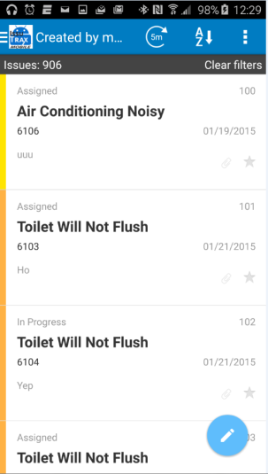

- “ITSMobile Android Device Configuration” to be read from database when avalalble. 8hrs
  - By default each app has a default configuration when installed. We need the ability to configure these settings from the database. We have created a table called “ITS.ITSMobileConfig” with the following fields:
    - ImageCompression int
    - EnableSessionLog bool
    - AutoSync bool
    - SyncFreq int
    - AdminPassword nvarchar(100)
If these values are set in the database they would be used on the device and the default values would be ignored. If the user goes into settings they will find that the controls are disabled in the device but the value that is taken from the db would be displayed.

ITS Mobile – Create:
- Check for duplicate open issues are required. (AIDA 4) 8hrs
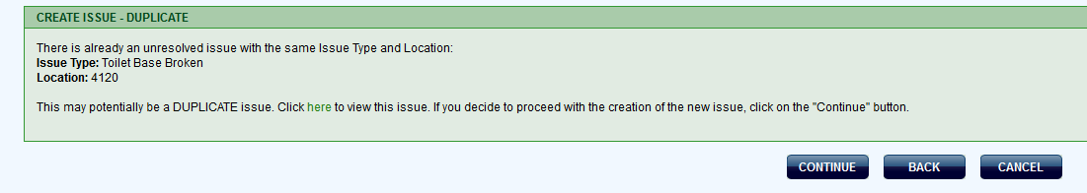
- Query for Guest details on Guest Service Issues 24 hrs
  - Please see below images as we will need to add the following
    - Date First Expericend
    - Cabin Number (Taken from Location field if location is a cabin, if not (such as restarnat) user will need to add guests cabin number to query by.
    - Guest Button which opens next dialog
    - Severity of issues/guest
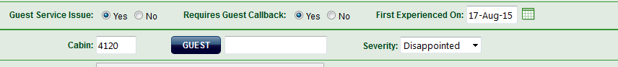

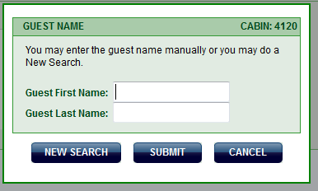

- Main Menu Issue Class buttons does not follow permissions for “Can Create” (AIDA 2)
  - If the user / department do not have access to create the buttons should not exist. 2hrs
- All Drop downs should default to “Select xxx” such as “Select Location Area” instead of first row of data. 4hrs
- When attaching an image, it should be compressed the same way we compress an image when it is taken with the camera. Example is if you press paper clip, select image, go to gallery and select a photo it will display invalid file size instead of trying to compress the image. (AIDA 1) 4hrs
- On login add a toast message that states “To create an issue manually swipe button right to left” 1hr
- “ITSMobile Create Android Device Configuration” to be read from database when avalalble.
Create issue app doesn't have any db .
  - By default each app has a default configuration when installed. We need the ability to configure these settings from the database. We have created a table called “ITS.ITSMobileCreateConfig” with the following fields:
    - ImageCompression int
    - EnableSessionLog bool
    - AdminPassword nvarchar(100)
If these values are set in the database they would be used on the device and the default values would be ignored. If the user goes into settings they will find that the controls are disabled in the device but the value that is taken from the db would be displayed.

ITS Mobile – Inspector:
- The “Automatic Synchronize” setting in “Update Settings” is disabled when no database exists which is correct. It should be enabled as soon as a successful hard sync is completed. Currently we have to hard sync, close the settings and then return to this dialog to enable the automatic sync. (aida 21) 2hrs
- We would like to display as many questions as possible on the inspections screen. Can you remove as much white space as possible while still allowing the question and notes to grow as required? Do you have any other ideas where we can get more questions per page? 4hrs Solved.
If the questions character size reduced to a limit, we can align the text part to screen's left and the button's position to the right so that all will keep a single line manner
- “Inspector Android Device Configuration” to be read from database when avalalble.
  - By default each app has a default configuration when installed. We need the ability to configure these settings from the database. We have created a table called “Inspector.InspectorConfig” with the following fields:
    - ImageCompression int
    - EnableSessionLog bool
    - AutoSync bool
    - SyncFreq int
    - AdminPassword nvarchar(100)
If these values are set in the database they would be used on the device and the default values would be ignored. If the user goes into settings they will find that the controls are disabled in the device but the value that is taken from the db would be displayed. 8 hrs

